

**Student Electronic Assignment Cover Sheet**

**Module Name:**

**Module Code:**

**Assignment Title:**

**Student Name(s):**

**Student Number(s):**

**Lecturer Name:**

**Word Count:**

**Date of Submission:**

TO BE UPLOADED VIA MOODLE.

I am aware of the DBS policy regarding cheating, plagiarism and all other forms of academic impropriety. The coursework submitted is my own and all other sources consulted have been appropriately acknowledged.

Signed:

___________________________________________________________________________

___________________________________________________________________________

VS

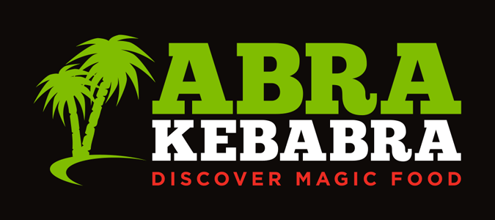

**Table of Contents**

1. Introduction & written Executive Summary ………………………………………………………………. 04
2. Company Background
3. Leo Burdock ….……………………………………………………………………………………………….. 05
4. ABRA-KEBABRA ………….………………………………………………………………………………….. 06
5. Situational Analysis ……………………………………………………………………………………………………. 07
6. Social Media Analysis………………………………………………………………………………………. 08
7. SWOT Analysis ……………………………………………………………………………………………….. 10
8. Persona ………………………………………………………………………………………………………….. 12
9. SEO Analysis
10. LEO BURDOCK …………………………………………………………………………………….. 14
11. ABRA-KEBABRA …………………………………………………………………………………… 16
12. RATER Framework ……………………………………………………………………………………………………… 18
13. Findings ……………………………………………………………………………………………………………………… 24
14. Recommendations …………………………………………………………………………………………………….. 25
15. Conclusion …………………………………………………………………………………………………………………. 27
16. Harvard References ……………………………………………………………………………………………………. 28
17. Bibliography ………………………………………………………………………………………………………………. 29

* Introduction & written Executive Summary

SME stands for Small and Medium Enterprises. So here by assignment I consider about two SME organizations which are. Leo Burdock and ABRAKEBABRA. Then compare and contrast them is the target of this assignment. Those two SME organizations are well deserved for people appreciation. Leo Burdock is organization which became everyone favorite in a short term of period. As well as the ABRAKEBABRA company also a company which is reach become more than millions of people favorite within a short-term period. After considering about those two organizations, I designed a Rater model to compare those two according to the Rater model details. After considering both. Leo Burdock gets higher Rate for everything I targeted. However, these two are kind of little bit complicated and little bit unclear details proven. Rater model describes the how much rate can give them separately. After and all you can identify references and also the prototypes here I made by.

As summary about those two organizations. Leo Burdock is which favorite among people relate the types of meat packages. ABRAKEBABRA also have them Not only meat packages but also some vegetarian packages also there. However, those two are kind of related two same kind of packages with special bonus sometimes. Whatever designs little bit not user friendly or attractive in both websites. Service is hopefully good as much as I identified.

In that case those two become people favorite. Social media also prove how demand they have. Qualify service both are given to the people. Website design have complicated, and images not found error. As well as I keep details also analyzing in a SWOT analysis which is define Strength, Weakness, Opportunities and Threats.

* Company Background

**Leo Burdock**

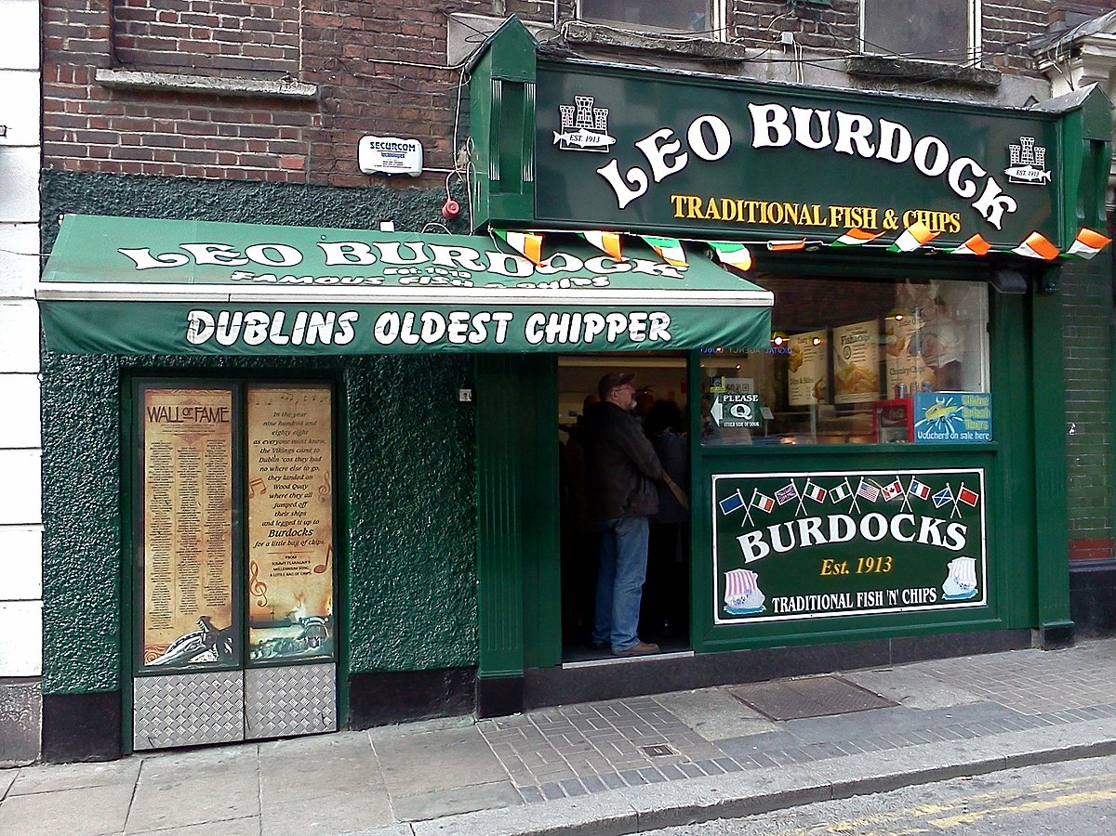

Burdocks was founded in 1913 by Bella Burdock in the Christchurch area of Dublin, [Ireland](https://en.wikipedia.org/wiki/Republic_of_Ireland). Together with her son [Leo](https://en.wikipedia.org/wiki/Patrick_Leo_Burdock), after whom she named the business, they opened a number of Leo Burdocks Fish and Chip shops around Dublin.

A number of the Burdocks were involved in the Irish Republican Army. In 1941, a stash of revolvers, rifles, hand grenades and ammunition were discovered concealed in a pram at the Marrowbone Lane shop during a police search. Joseph Burdock took responsibility to ensure his father was not implicated. The lack of fuel and ingredients during the [Second World War](https://en.wikipedia.org/wiki/Second_World_War) forced the closure of all but the original location.

**ABRAKEBABRA**



ABRAKEBABRA is famous restaurant which is supplying fast food for the customer. It I located in Ireland. ABRAKEBABRA is known for its astounding extend of Kebabs, Burgers, Baguettes, Stacked Fries and more.

From classics such as the Downer Kebab and Taco Fries to more current advancements like Stacked Fries and Naked Kebabs, ABRAKEBABRA has been making striking, flavorful nourishment for over 38 a long time. **(Abarekebabra, 1982)**

* Situational Analysis

When go through about the Digital Marketing Strategy (DMS), it emphasizes that the discipline of the creativity and intelligence that the combination of science, business management and Art. Therefor marketing planning is a systematic process that includes the marketing environment and tactic to chive the marketing objectives. The basic role in here is to be generate leads and build the brands recognition by using many kinds of digital marketing such as,

* Social media
* online advertisements
* websites
* email notifications
* Email marketing
* Content Marketing
* Affiliate Marketing
* Data Analysis
* Digital Technologies

In this dynamic environment, product user’s needs are changing constantly in each and every time. To be succeed in digital communication, marketers need tools and techniques for connect with consumers across touchpoints. Social media marketing (SMM) play an important role in here when considering about both LEO BURDOCK and ABRAKEBABRA. The greatest benefits of using social media is that, its accessibility and affordability. There are various kind of platforms of social media marketing which can be adopted by LEO BURDOCK and ABRAKEBABRA as the business practitioners to promote their products.

According to the Rater model it gives a high priority for the social media marketing platform. Both two companies are mainly marketing their product by using this method mostly. Both websites have a better looking but it gives a selection rather than using a search bar. It is very essential to have a better understanding about how the search engine marketing (SEM) works.

|  |  |  |
| --- | --- | --- |
|  |  |  |
| Facebook |  |  |
| Instagram |  |  |
| Twitter |  |  |
| YouTube | @leoburdockireland  42 subscribers | @AbrakebabraOfficial  298 subscribers |
| Linkdin | **­-** |  |

* **Social media Analysis**

Many companies, include LEO BURDOCK affiliate programs but ABRAKEBABRA is not much using affiliate marketing. It’s an easy way to outsource your digital marketing without an upfront cost. Sometimes LEO BURDOCK do not directly promote their products and their services instead of incentivizing other content creators to advertise the product and their services. So, it is a disadvantage in here to the company, ABRAKEBABRA than LEO BURDOCK. When considering about digital marketing owners may depend on whether the target audience is a business or consumers or users. So that, according to the LEO BURDOCK and ABRAKEBABRA are targeting users, so that they could be able to use digital marketing to market the brand of the product.

Digital marketers ensure virtual content is truly useful and relevant to solve your customers’ issues. When go through the two companies, content marketing, data analytics and using digital technologies take a medium priority or lower but when we considering about the content marketing, it involves creating assets which may answer specific questions in the user’s mind. They should also going to be noticed about the latest kind of changes and adapt them in to new standards.

When considering about the Competitors & Target Audience, the important thing is that the digital marketer must have a better understanding about how to use various aspects of technologies when doing marketing. Therefore, they should also need to stay informed about the latest changes and also have to adapt quickly to the new standards of the product. Thus, when go through about the two companies both of them are fulfilled that standard as much as they can. Therefore, the marketer can keep their target audience with them without any disturbances. So, LEO BURDOCK had a large target audience as same as the ABRAKEBABRA, but it could be able to get a high priority of having the target audience LEO BURDOCK better than ABRAKEBABRA.

* **SWOT Analysis**

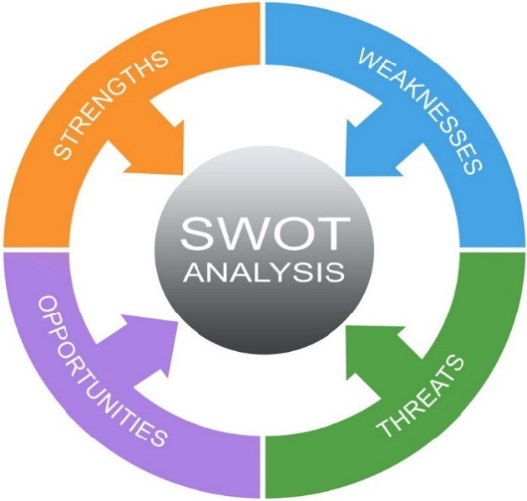

They hope to reach their Target Audience the SWOT model is very essential to reach to their goals to both companies by using Strengths, Weaknesses, Opportunities, and Threats of their marketing communications and the competitive activities. When analyzing the companies to SWOT model, Both Leo Burdock and ABRAKEBABRA have more similar Strengths, Weaknesses, Opportunities, and Threats as they have same Competitors & Target Audience.

* **Strengths**
* Having a popular Brand name and high brand loyalty
* Quality of the products and
* Giving a quick service to the customers
* Having a good advertising and marketing through social media and television
* Making Unique products
* More than 200+ employees with both companies.
* Perfect Customer loyalty
* **Weaknesses**
* Quality product management is a biggest challenge.
* Giving quality service is a massive challenge.
* Limited market
* High quality brands are coming to the market
* **Opportunities**
* Venture more into home delivery
* New products and new food preparations with different flavors can help to grow the both brand names.
* Both brands can venture into newer market
* **Threats**
* Because of the health conscious, people avoid fast foods.
* Threats from competition can be decline the shares of the market of both brands.
* Rising the price of special ingredients.
* 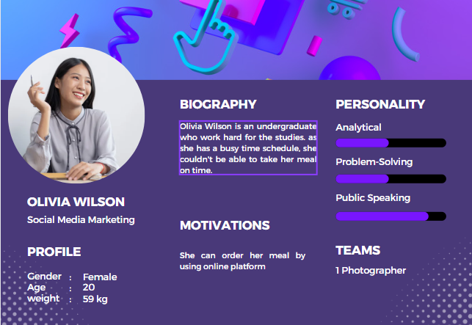**Personas**

Fig: 1

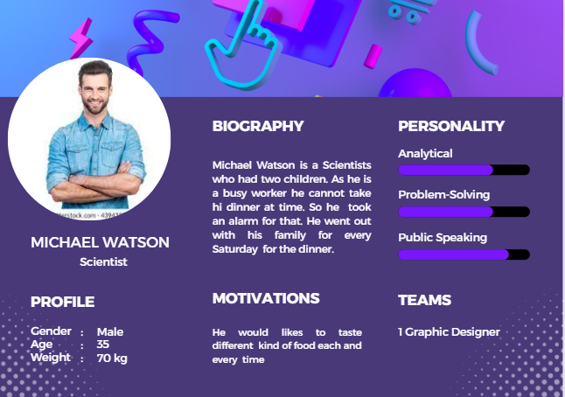

Fig: 2

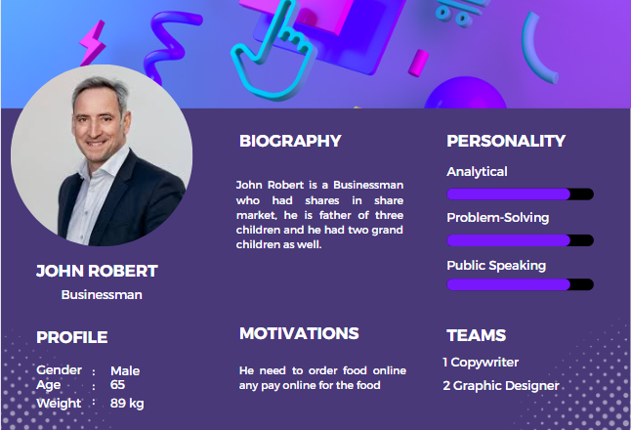

Fig: 3

According to the three personas it shows the companies might have a specific audience in mind, but don’t know whether marketing mediums reach them or not reaching them at all. So however both LEO BURDOCK and ABRAKEBABRA makes it easier to ensure to reach the right people for their content. To take a better understanding and to fulfill usability goals both company may really helpful these kind of things as much as they can to get rid of failures.

* **SEO Analysis**
* **LEO BURDOCK**

**Internal pages**

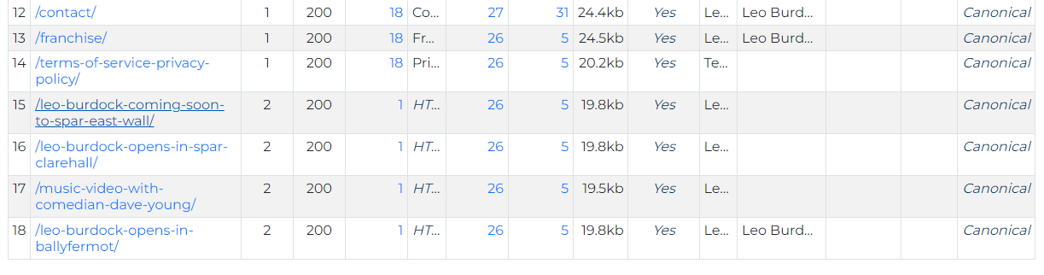

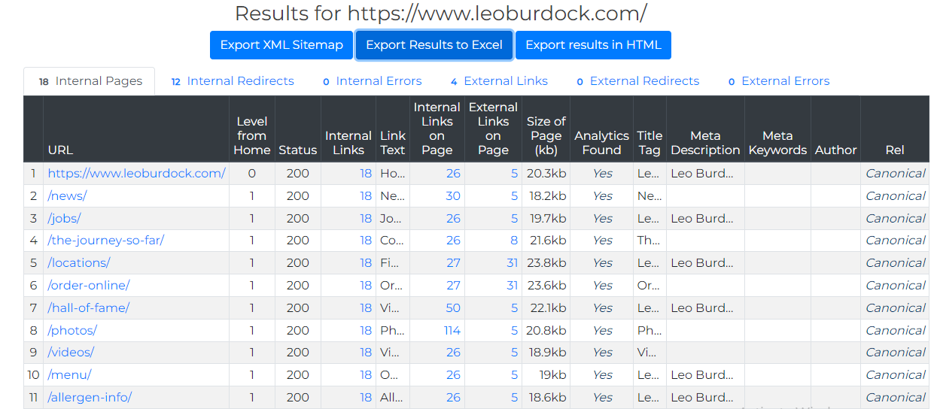

* There are 18 internal pages we could found in Leo Burdock.

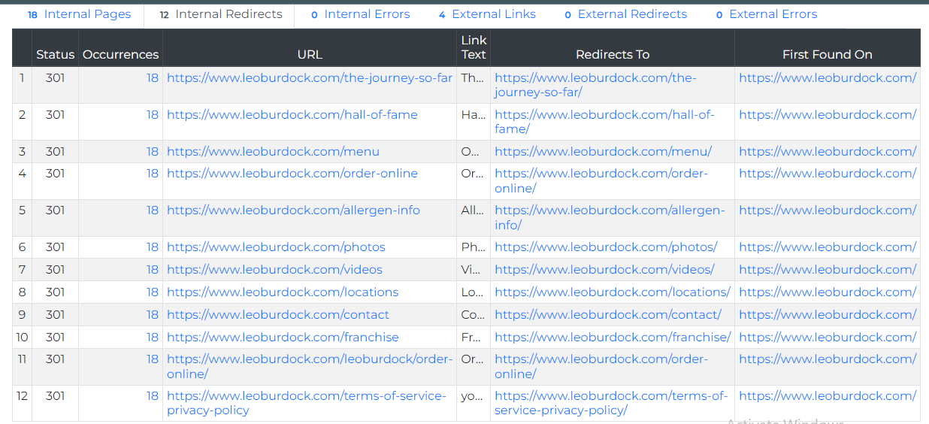**Internal Redirects**

* There are 12 internal redirects we could found in Leo Burdock.

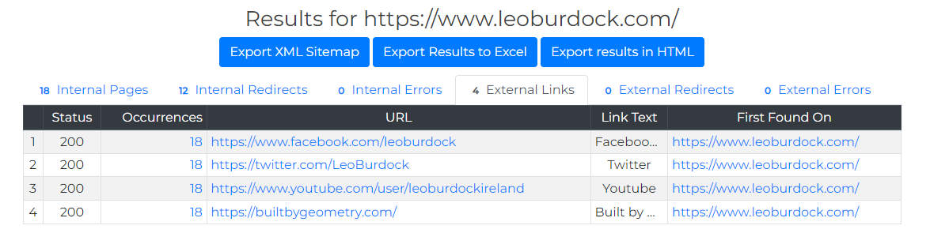

**External links**

* There are 4 external links, we could found and in Leo Burdock.
* There is no any external redirects as same as external or internal errors.
* **ABRA-KEBABRA**

**Internal Redirects**

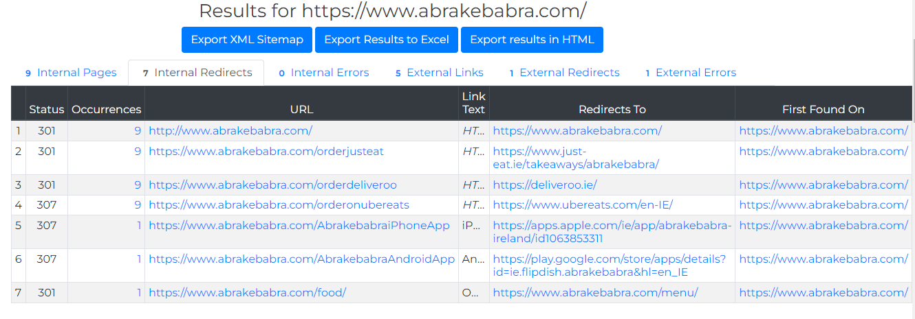

* There are 9 internal pages we could found in Abra-kebabra.

**Internal pages**

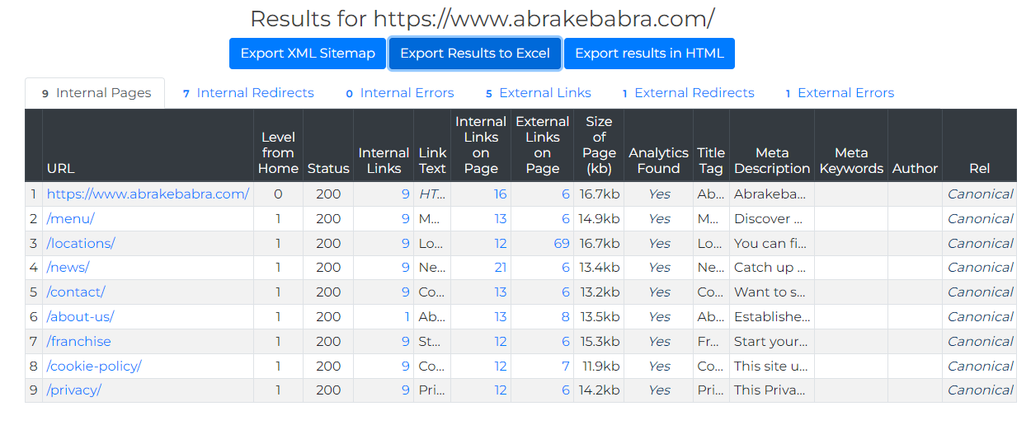

* There are 9 internal pages we could found in Abra-kebabra.

**External links**

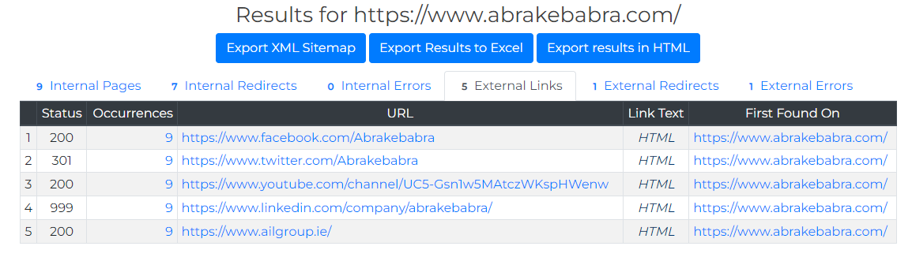

**External errors**

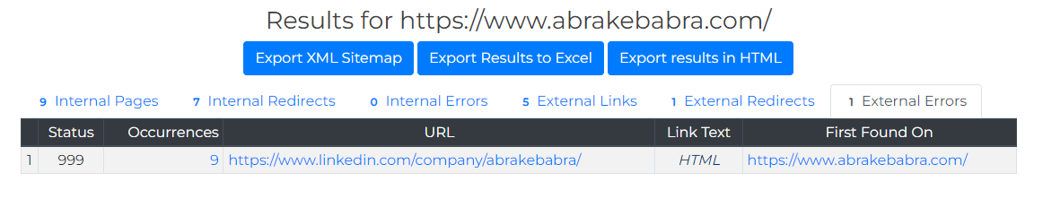

* There are 5 external links we could found in Abra-kebabra.
* In here there are no any external error and one external error in Abrakebabra.
* RATER Framework

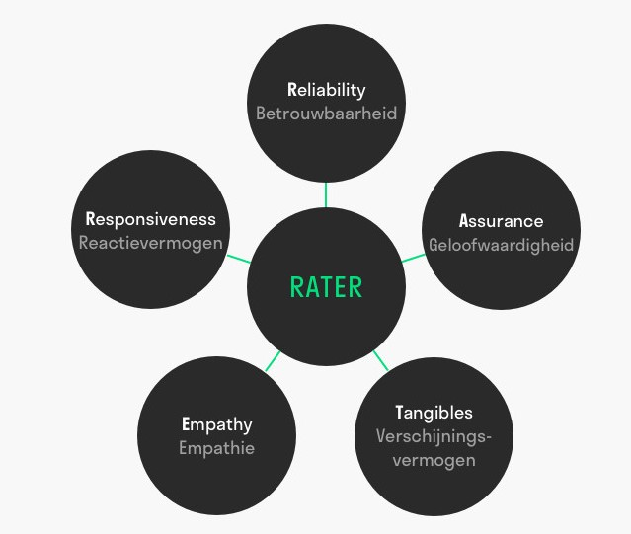

Rater framework describe about five sectors which are,

* Reliability
* Assurance
* Tangibles
* Empathy
* Responsiveness

According to those of sectors I design and compare those two SME organizations. So that my opinion about those two, detailed report of SME analysis has been given below.

Fig: 4

Fig: 5

Fig: 5

Fig: 6

Fig: 7

Fig: 8

Fig: 9

So in here under the five sectors rater model is define. Firstly here discus about Reliability. So under reliability there are sections like Brand Presence, Favorite Icon, domain address, security like wise. Under those section reliability take place of the ABRAKEBABRA organization took 65% rate. LEO BURDOCK take 80% rate. Those two has huge gap of reliability.

Those two SME has great Brand Presence People favorite icon also high rate of amount. High range of domain address have both of them. But we consider about the security of the organizations LEO BURDOCK supply best security than the ABRAKEBABRA. Both of the Link Analysis are high. But broken links Is low of LEO BURDOCK . But the ABRAKEBABRA Broken link section is high. We considering about the speed of the website both of them are high.

Performance level is best in LEO BURDOCK more than the ABRAKEBABRA. Contact details phone number, social media links and social media content has high priority in those two organizations. Email response and content is having medium level in ABRAKEBABRA but those two sections of LEO BURDOCK represent High level. Call to action Navigation and email response have medium level of priority for those two organizations. Language comprehension represents low level of priority in ABRAKEBABRA. But in LEO BURDOCK it also represent high level. Price list demand also low in ABRAKEBABRA. But in LEO BURDOCK has high.

Now consider about the Assurance sector. Under assurance sector consider about the all kind of sections under it ABRAKEBABRA get 55 percentage of rate and the LEO BURDOCK get 75 percentage of rte. Here also ABRAKEBABRA get low range of rate more than LEO BURDOCK . Terms and conditions, , sites and supplier details plays High level performance related to both of organizations. Both of organizations security is medium in this sector.

When we consider about privacy policy and cookies notice ABRAKEBABRA get high range but LEO BURDOCK get medium level;. Video, design & content and also the testimonials sections have high range for LEO BURDOCK but low range for ABRAKEBABRA. FAQ, Website up to date and reviews has medium level for ABRAKEBABRA and the other one LEO BURDOCK has high level. As well as usability and social media engagement of the Assurance sector LEO BURDOCK has high range mark but the ABRAKEBABRA has medium level range. Totally in assurance sector LEO BURDOCK range is higher than the ABRAKEBABRA. So however in here also rate range gap is high.

Then consider about the Tangible criteria, in this sector also higher rate earn by the LEO BURDOCK . In here by sections in physically appearance ABRAKEBABRA in medium level. But the LEO BURDOCK has High range. Text content quality of ABRAKEBABRA is Low level but the LEO BURDOCK have high level of text content. While considering Branding also LEO BURDOCK have high level but unfortunately ABRAKEBABRA has medium. Two of Enterprises have high range of quality image, Newsletter and stories. But the both of the Blog is Medium. ABRAKEBABRA has medium level of social media followers unlike LEO BURDOCK . LEO BURDOCK has high level of media followers. App also ABRAKEBABRA has medium level and LEO BURDOCK have high level. Both of the companies Employee images are low level. Totally ABRAKEBABRA has presentably 70 range. And LEO BURDOCK has 85% range. Here range difference is some but low.

Now comparing the Empathy of both organizations LEO BURDOCK has extremely high range of percentage like 92%. But the ABRAKEBABRA has not low range but it is low than the LEO BURDOCK . It is 75%. It also a good range. The hand of Empathy side both of organizations prove more than half of sectors high level performance. Only for the DM sector LEO BURDOCK proving Medium level Performance. Other all sections it displays high level range. Online payment, Tone of voice, help options and response to the client sections of ABRAKEBABRA proves medium level. Other sections it also display high capability. So that in the empathy side both of the companies are done great.

Last but not least Responsive sector both of the company proving great level. LEO BURDOCK displays 85%, and ABRAKEBABRA displays 70%. Distance range little bit close. Both of the sections live chat has low range. As well as both of the companies DM response and comment response is medium level. Other sections of LEO BURDOCK displays high level. Both of the sections are extremely mobile friendly. As same as both of companies have high level for email response, phone response, loading page speed, social media links, website links, form filling and image handling.

Considering navigation menu ABRAKEBABRA has low level performance but LEO BURDOCK has high level. Website functionality also ABRAKEBABRA is medium and LEO BURDOCK is high. So that LEO BURDOCK is performance and functionalities are higher than ABRAKEBABRA according to my rater model. Totally LEO BURDOCK is high range value more than ABRAKEBABRA. Last image shows how range of capability earned by all of the sectors separately.

* Findings

As much as the both marketers emphasize their discipline as science, much of marketing is art as digital marketing. So that the variables and indicators of both LEO BURDOCK and ABRAKEBABRA of the success are moving to their targets as much as they can. The Marketers has a better undertaking about research. They hope the research will help them understand the SWOT model such as Strengths, Weaknesses, Opportunities, and Threats of their marketing communications and the competitive activities.

When considering about the issues or problems that affect the marketing communications for the brands are, it may simply categorized such as,

* Competitors
* Confusing over marketing tactics and strategy
* Effectiveness of brand
* too much analysis and no action
* Inadequate resources
* a volatile environment
* Lack of marketing intelligence system
* In-house, out-house staffing
* a culture that does not support planning
* Learned messages

Comparing both LEO BURDOCK and ABRAKEBABRA, both of the brand got same target audience. Therefore, both of the companies have same competition with each other, but both of them distribute different kind of products to the customers. Because of lack of marketing intelligence system, we can see the insufficient understanding of customer behavior and poor understanding of the environment.

When considering about confusing over marketing tactics and strategy, it play a role as the biggest barrier for most of the organizations that has poor understanding of the marketing planning process and the payment planning too. Because of lower grasp of the marketing concepts and lack of skills and knowledge it inadequate resources. When go through form the issues, purchasing the product, changing product perceptions, and increasing the intention to buy are the some of the issues that it elicits the desired customer responses.

* Recommendations

Any of the companies demand always depend on firstly people’s first impression. In a website first impression cannot be taste it‘s fully depend on the website creativity. According to rater model it analysis under the five sector how well are performance of the company. LEO BURDOCK is demand for the meat related product anyone know how it is taste. ABRAKEBABRA also one of famous and branded company with several food items. But some of reason those both companies can achieve 100% range for the Rater model I design. Therefore consider about why. ABRAKEBABRA get Medium rate for security. As a company if it can be high it will increase the demand of it. As a website its performance should be great. According to my opinion ABRAKEBABRA Company has lack of performance.

Language comprehension has low level mark. Design, videos supply and also the content are not well organized. Those are the things company should be carefully about to maintain. If those things are not covering it will really affect to the company reputation. Customer attraction always depend on their first impression. Less attractive pages belongs sites are not going the people heart. As a result of that one day that company can be bankrupt or closed. Images should be added. Additionally well performance websites always add some of videos to get the customer attraction. Image s are main part of website, so that reason always try to add quality images. Consider about sizes of images I saw lot of times images has not in same size. And some of times band and name is there but image is missing. It create usability issues hardly. It is not good for the company. And the other hand live chat, both of companies got low mark for this.

Granted company should be have live chat area because it can increase the trust and companion between the customer and the company. Trust is importantly of profit maximization. Then regarding the details and content, accuracy those are also should have high priority. Customers are people who looking for product demand and value. As well as content. Those are cannot be poor. Content is something describes the product value. When the content become attractive, people attention to the product go high. It will increase the organization profit. If not that company any product go down and revenue of the sales go down. As a result of that scarcity also can happen. If scarcity occur at least some of demandable products launch also become down. After and all company will closed forever.

So considering about all of this my recommendation is company should consider about below details and recreate the websites. And make website appearance great. Add some more details to less details included sectors. Make website attractive by using qualify images, And also add some attractive videos. To make use of app easier to people add some of videos. Because all of customer are not familiar with websites. Contact them easily. Response the messages or email within at least 15 minutes. If the employer cannot reach customer easily due to some of security technical issues add auto generate, message to the customer describe about the lateness. Add some terms and conditions to maintain security.

To gain the trust of customer and also the make the employer feel valuable about them to add some of employer images. Add some video contains how the service gains by customer to their door. Nowadays lot of sites using Blogs. So blogs become valuable part of companies. But here those of company medium level for blog. Recere4ate or add Blog for the site. According to my opinion those kinds of recommendations can be advantage able to the companies grain which I consider as two SME organizations.

* Conclusion

Started in 1913 when Liberties residents Bella Burdock and husband Patrick opened the first Leo Burdocks in Christchurch, Dublin. Over the years, The Burdock family grew their business and opened many Leo Burdocks Fish & Chip shops around Dublin, such as the popularity of their food. From a young age, their son Leo was a regular face in the early morning Dublin fish markets, rising at 5 am most days to source the freshest catch. Travelling back by horse and cart with his haul, he would pick up fresh potatoes and coal for heating the Pans, a fuel used up until 1991 to cook the freshly prepared Fish and Chips, at this point they were the last chip shop in Ireland, possibly the world to use these coal-fired pans. **(Burdock, n.d.)**

ABRAKEBABRA is famous restaurant which is supplying fast food for the customer. It I located in Ireland. ABRAKEBABRA is known for its astounding extend of Kebabs, Burgers, Baguettes, Stacked Fries and more. From classics such as the Downer Kebab and Taco Fries to more current advancements like Stacked Fries and Naked Kebabs, ABRAKEBABRA has been making striking, flavorful nourishment for over 38 a long time. **(Abarekebabra, 1982)**

According to my research however for the more customer attraction websites also be grain Actually LEO BURDOCK ad this ABRAKEBABRA also one of the major companies as restaurant. Thy are very famous. But considering about some services and website preference are not well organized. They should be updated. The more they are updating their services and performance that much they can gain profit. It will deeply helpful for the profit maximization. Digital marketing hit in the industry. So that much time period website are the demand and reputation of the company. So that reason people are recommending company not only for the performance but also for the appearance. Therefore, some of the functionalities in here to be update. As well as some of services can be prove to gain. Otherwise digitally marketing of the service can be down.

* Harvard References
* <https://www.abrakebabra.com/about-us/> (Abarekebabra, 1982)
* [https://www.coursehero.com/file/p20bmgia/In-conclusion-LEO BURDOCK -as-a-well-known-and-advanced-fast-food-product-store-generally/](https://www.coursehero.com/file/p20bmgia/In-conclusion-KFC-as-a-well-known-and-advanced-fast-food-product-store-generally/) (Anon., n.d.)
* <https://www.indeed.com/career-advice/career-development/how-to-write-a-conclusion-for-a-research-paper> (Anon., n.d.)
* <https://praxie.com/rater-model-online-tools-web-templates/#:~:text=The%20RATER%20Model%20is%20a,your%20service%20provision%20is%20assessed>. (Anon., n.d.)
* [Create powerful business content together with Xtensio](https://xtensio.com/) (Anon., n.d.)

# Bibliography

Abarekebabra, 1982. *Abarekeababra website.* [Online]   
Available at: https://www.abrakebabra.com/about-us/

Anon., n.d. *Conclusion.* [Online]   
Available at: https://www.scribbr.com/research-paper/research-paper-conclusion/

Anon., n.d. *information gatering.* [Online]   
Available at: https://www.ukessays.com/essays/marketing/kfc-one-of-the-famous-fast-food-restaurant-marketing-essay.php

Anon., n.d. *Persona Template.* [Online]   
Available at: https://xtensio.com/

Anon., n.d. *Rater Model.* [Online]   
Available at: https://praxie.com/rater-model-online-tools-web-templates/#:~:text=The%20RATER%20Model%20is%20a,your%20service%20provision%20is%20assessed.

Burdock, L., n.d. *info about Leo Burdock.* [Online]   
Available at: started in 1913 when Liberties residents Bella Burdock and husband Patrick opened the first Leo Burdocks in Christchurch, Dublin. Over the years, The Burdock family grew their business and opened many Leo Burdocks Fish & Chip shops around Dublin, such as

Burdock, L., n.d. *Leo Burdock wikipidea.* [Online]   
Available at: https://en.wikipedia.org/wiki/Leo_Burdock